

**EVOLUTION101**

**WEEK 2: VIDEO RESOURCES & READING MATERIAL**

1)Mechanisms of Evolution

* [Neo-Darwinism](https://youtu.be/f3UqRb7P64E?feature=shared)
* [Modern Synthetic Theory of evolution](https://youtu.be/QtycXzafE-0?feature=shared)

**MODERN SYNTHETIC THEORY OF EVOLUTION**

1. **What is It?**

It is the updated version of Darwin’s theory of evolution.

Also called the Neo-Darwinian theory.Developed in the 1930s–1940s by scientists like Julian Huxley, Theodosius Dobzhansky, Ernst Mayr, and others.It combines ideas from Darwin’s natural selection, Mendel’s genetics, and modern molecular biology.

2. **Why Was It Needed?**

Darwin explained evolution by natural selection, but he didn’t know how traits were inherited.

After Mendel’s work on genes became popular, scientists realized that genes control traits.

connects evolution with genetics, mutations, population studies, and molecular biology.

3. **Main Components**:

**a. Gene as the Unit of Inheritance :**Genes are segments of DNA that decide traits.

Traits are passed from parents to offspring through genes.

b. **Mutation :** Random changes in genes (mutations) introduce new traits or variations.

Some mutations are helpful and can improve survival or reproduction.

c. **Genetic Recombination :** During sexual reproduction, gene mixing occurs.

This creates variation among individuals even without mutations.

d. **Natural Selection :** Nature “selects” the best traits that help survival and reproduction.

Individuals with useful traits survive longer and produce more offspring.

e. **Genetic Drift :** In small populations, random chance can cause gene frequencies to change. This is not based on survival or usefulness, just pure luck.

f. **Gene Flow (Migration) :** When individuals move between populations, they carry their genes with them. This causes mixing of traits and increases variation.

g. **Isolation :** When a group of organisms gets separated (by mountains, rivers, etc.), they evolve separately. Over time, they may become new species.

4. **What Does It Explain?**

* How new species evolve from old ones?
* Why we see such a huge variety of life forms?
* Why certain traits become common in a population over time?
* How genetic changes and natural forces together drive evolution?

5**. Importance of the Modern Theory :** It is the most accepted explanation of evolution today. It helped create new fields like population genetics, evolutionary biology, and conservation biology. It shows that evolution is a slow, continuous, and multi-step process.

6. **Differences from Old Darwinism**

| **Aspect** | **Darwin’s theory** | **Modern Synthetic Theory** |
| --- | --- | --- |
| Focus | Survival of the fittest | Genetic changes + selection |
| Knowledge of genes | Not known | Fully included |
| Source of Variation | Unknown | Mutation + recombination |
| Randomness | Less random | Includes random changes (genetic drift) |
| Species Formation | slow | Can be faster due to isolation and mutations |

7. **Conclusion** :

The Modern Synthetic Theory is like a full recipe for evolution: it includes the ingredients (genes, mutations, variation) and the cooking method (natural selection, drift, isolation).It gives a complete and scientific explanation of how all living things have evolved and continue to change over time.

**MECHANISM OF ORGANIC EVOLUTION**

**Organic Evolution** :“Changes in the genetic makeup of species in a population as a result of responding to environmental changes is organic evolution”

( How living things change and evolve over time)

The phenomenon of **genetic variation** is basic for organic evolution. It is upon this that selective forces act for evolution to take place. The mechanism of evolution emphasizes on:

* Descent and genetic differences which can be inherited to the next generation. Genetic drift, migration, mutation, natural selection as mechanisms of change
* Significance of genetic variation
* Consequences of a reduction in genetic variation and random nature of genetic drift
* Impact of various species on each other’s evolution process via co-evolution
* Role of differential reproduction, variation, heredity in evolution by natural selection

Evolution is observed in a population as it contains genes in the gene pool, changes in this pool cause evolution.

The mechanism of organic evolution refers to the processes and forces that cause changes in organisms over generations, leading to the formation of new species. These are the tools used by nature to bring about evolution.

1. **Variation**

**Definition**: Differences in traits among individuals in a species (like height, color, speed, etc.).

**Sources**:

* Genetic mutations (random changes in DNA).
* Genetic recombination (mixing of genes during sexual reproduction).

**Importance**: Variation is the raw material for evolution — without differences, there’s nothing for nature to “select.”.

2. **Mutation**

**Definition**: A sudden, random change in the gene or DNA of an organism.

It is a driving force for evolution. It can be a random change in the genetic composition having an impact on the gene pool of a population. This alteration in the nature of DNA in 1 or more chromosomes produces new alleles, hence a cause for genetic variation. **Natural selection is decisive in mutation to eliminate the less-fit, allowing survival of the fittest.**

**Types**:

* Beneficial (helpful)
* Harmful (harm the organism)
* Neutral (no effect)

**Role in evolution**: Introduces new traits that may help the organism survive better.

3. **Natural Selection**

**Definition**: The process by which nature selects the individuals that are best suited to the environment.

It occurs when entities are left up to an environment where **survival of the fittest** is observed. These characteristics when inherited in offspring reproduce a population better suited to the changing environment. Traits from less-fit entities are less likely to be passed to the upcoming generation. In natural selection, the significant selective force is the role of the environment.

**Steps**:

* More individuals are born than can survive.
* There’s competition for food, space, mates.
* The ones with advantageous traits survive and reproduce.
* These traits get passed to the next generation.

4. **Genetic Drift**

**Definition**: A random change in gene frequency in a small population due to chance.

It can take place when a small population moves to a new geographical location, establishing in a completely isolated area.

Examples:

* When a few fishes are introduced in a lake, the population evolves over time into a different one from the parent ones. This process does not take place in densely populated areas.
* If a few individuals die accidentally (like in a flood), their genes are lost.

**Effect**: Can reduce genetic diversity and sometimes lead to new species by accident.

**Founder Effect:**

* The founder effect is a specific case of genetic drift. It occurs when a small group of individuals becomes isolated or separated from a larger population to form a new, isolated population.
* The founder effect leads to lower genetic diversity in the new population compared to the species as a whole. This phenomenon can result from natural disasters, such as volcanic activity or sudden flooding, creating new environments for small groups.

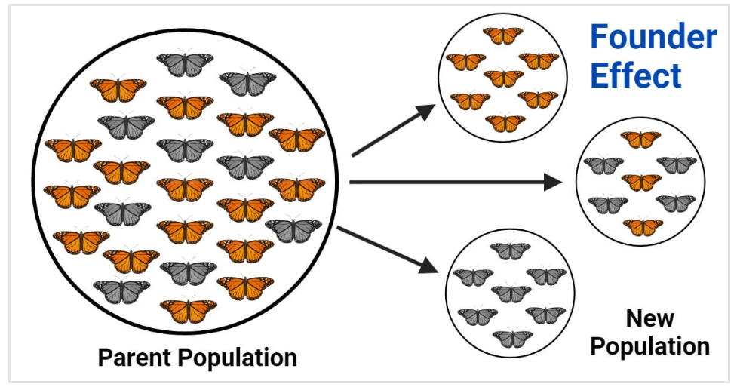

5. **Gene Flow (Migration)**

**Definition**: Movement of genes from one population to another.

Migration of entities may cause a cluster of them to move to a new geographical location. When the migratory entities interbreed with the newly introduced population, they result in the addition of new genes to the already existing gene pool as a result of the local population, thereby contributing to the gene flow.

**Effect**: Increases variation and helps spread useful traits between groups.

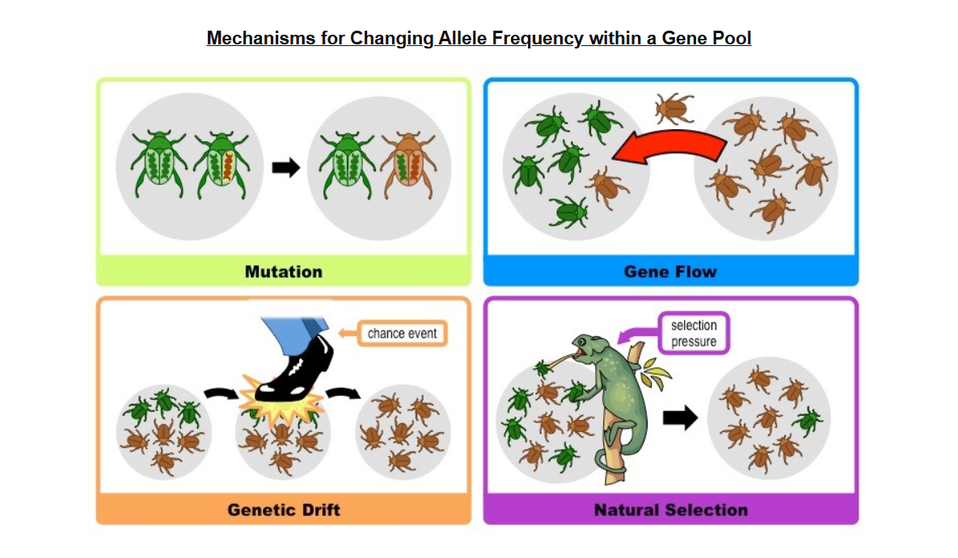

6. **Isolation**

**Definition**: When a group of organisms is separated from others (by geography, behavior, or time).

**Types**:

Geographic isolation: Mountains, rivers, oceans separate groups.

Reproductive isolation: Changes in mating behavior or timing.

**Effect**: Prevents mixing of genes, so the isolated group may evolve differently and become a new species.

7. **Adaptation**

**Definition**: A trait that helps an organism survive or reproduce better in its environment.

Can be structural (e.g., long neck of giraffes), behavioral (e.g., migration), or physiological (e.g., sweating).

Adaptations develop over time through natural selection.

8. **Speciation**

**Definition**: The process of forming new species.

Happens when populations become so different (due to mutation, selection, isolation) that **they can no longer interbreed.**

**Result**: Two different species with their own gene pools.

9. **Survival of the Fittest**

Introduced by Herbert Spencer, and supported by Darwin.

“Fittest” doesn’t mean strongest, but **the ones best adapted to survive and reproduce in their environment.**

10. **Role of Environment**

* The environment acts as a filter, selecting which traits are useful.
* As the environment changes (climate, food availability, predators), the organisms must adapt or go extinct.
* Evolution is continuous and dynamic because the environment keeps changing.

**Conclusion**:

The mechanism of organic evolution is a natural, slow, and step-by-step process driven by:

* Variation
* Mutation
* Natural selection
* Genetic drift
* Migration
* Isolation

Together, these forces shape the diversity of life we see on Earth today.

2) Hardy Weinberg Principle

* [Hardy Weinberg Equilibrium](https://youtu.be/7S4WMwesMts?feature=shared)
* [Example Problem](https://youtu.be/mpm8-pTEmJ4?feature=shared)

## **Hardy–Weinberg Principle (Hardy–Weinberg Equilibrium)**

### **1. What is the Hardy–Weinberg Principle?**

* The Hardy–Weinberg Principle is a **mathematical model** that helps **predict how genes (alleles)** will behave in a population **if no evolutionary forces are acting**.
* It tells us that **allele and genotype frequencies** in a population will **remain constant** (i.e., be in equilibrium) from one generation to the next if certain ideal conditions are met.
* This model was **independently proposed** in 1908 by:
  + **G.H. Hardy**, a British mathematician.
  + **Wilhelm Weinberg**, a German physician.

### **Allele Frequency :** The proportion of a specific **allele** (variant of a gene) in a population relative to all alleles at that gene locus.

### 

### 

### **2. Why is this principle important?**

* It provides a **baseline or reference point** to study real-world populations.
* If actual data **deviates from the expected values**, it indicates that **evolution is happening**.
* Helps scientists **detect evolutionary forces** such as natural selection, gene flow, or genetic drift.

### **3. The Mathematical Formula**

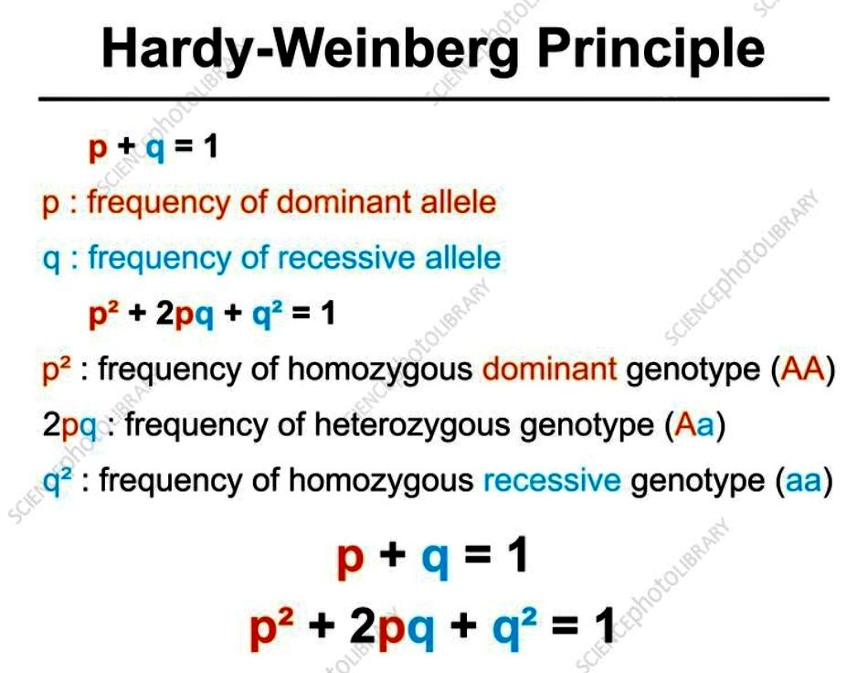

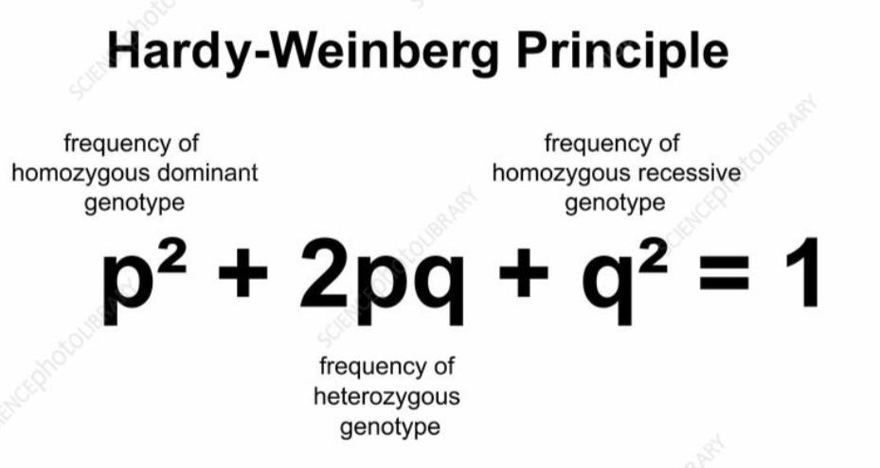

The principle uses a **simple equation** to calculate genotype frequencies based on allele frequencies.

#### **Let:**

* **p** = frequency of the **dominant allele** (e.g., A)
* **q** = frequency of the **recessive allele** (e.g., a)

Since there are only two alleles:

* **p + q = 1**

Now, to calculate genotype frequencies:

* **p²** = frequency of **homozygous dominant** genotype (AA)
* **2pq** = frequency of **heterozygous** genotype (Aa)
* **q²** = frequency of **homozygous recessive** genotype (aa)

So, the full equation is:  
 **p² + 2pq + q² = 1**

This formula helps estimate:

* How many individuals are carriers of a gene.
* How many are likely to show a dominant or recessive trait.

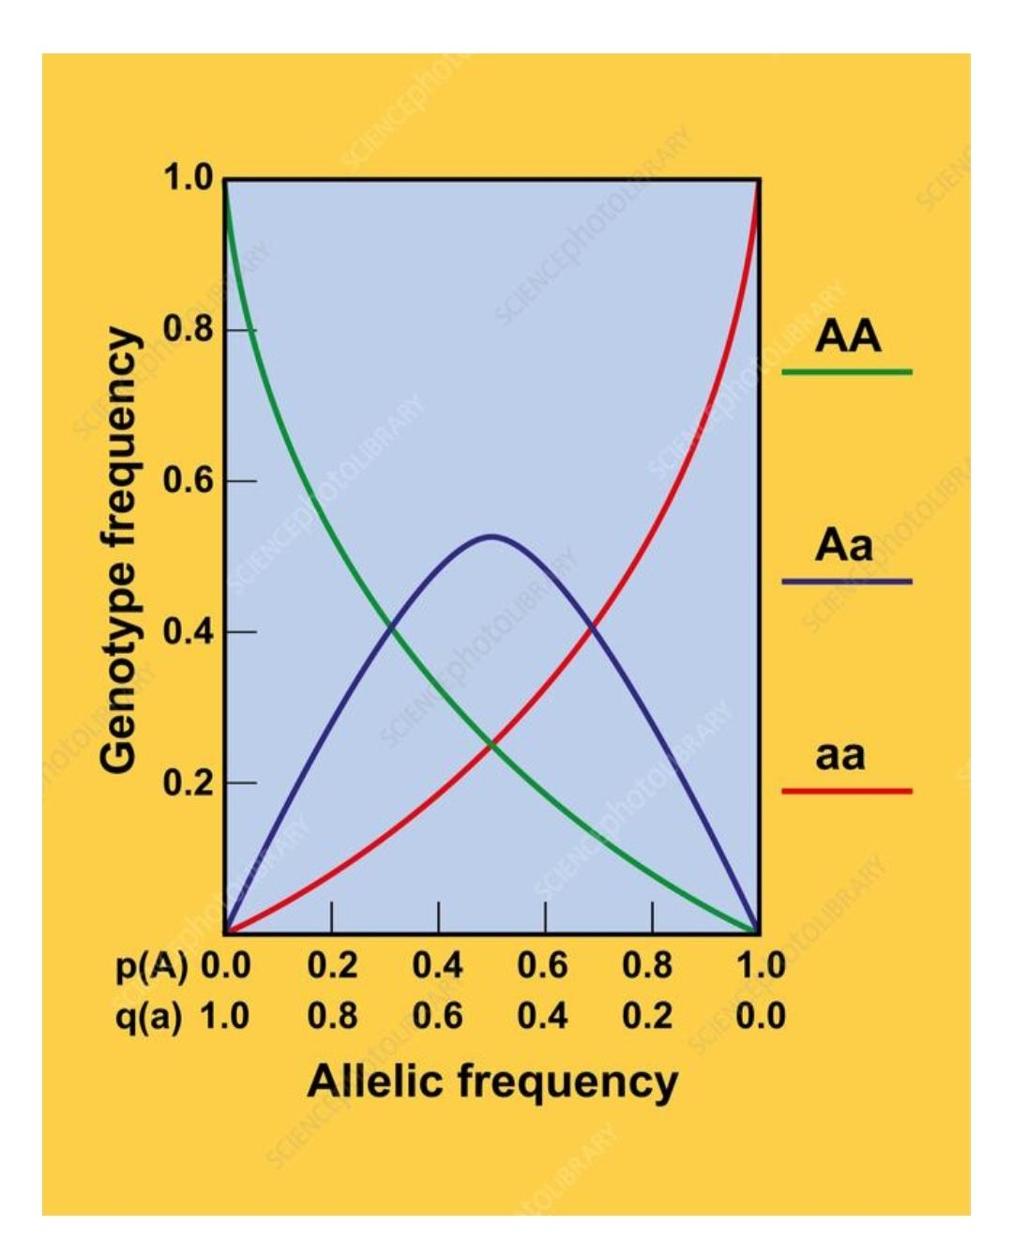

### **4. Assumptions/Conditions for Equilibrium**

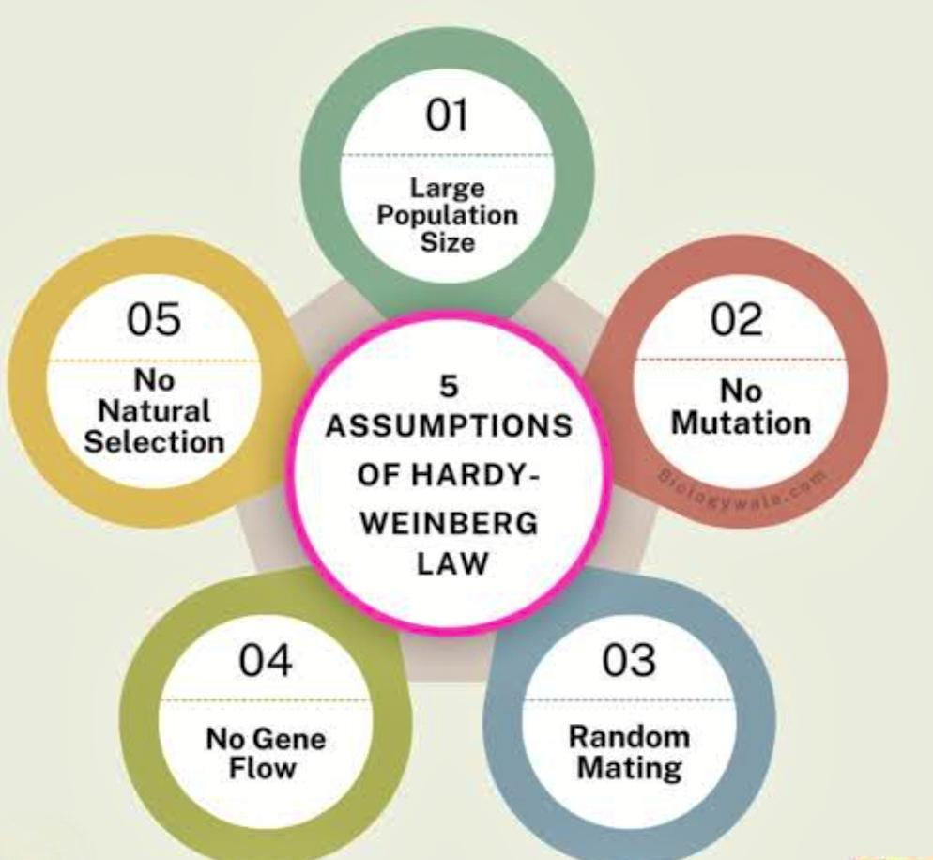

For a population to **remain in Hardy–Weinberg equilibrium**, these **5 conditions must be met**:

#### **a. No Mutation**

* DNA should not change. No new alleles should be created or existing ones altered.
* If mutations occur, they can introduce **new traits**, which **will change allele frequencies.**

#### **b. No Migration (No Gene Flow)**

* Individuals should not **enter (immigrate)** or **leave (emigrate)** the population.
* Migration brings **new alleles** into a gene pool or removes existing ones, disturbing equilibrium.

#### **c. Very Large Population Size**

* The population should be large enough to **avoid random changes** in allele frequencies.
* In small populations, **genetic drift** (chance events) can cause big changes, leading to evolution.

#### **d. Random Mating**

* Mating should occur **by chance**, not based on traits or preferences.
* If individuals mate selectively, some traits will be passed more than others, disturbing equilibrium.

#### **e. No Natural Selection**

* **All genotypes should have** **equal chances of survival and reproduction**.
* If one trait gives an advantage, it becomes more common — and evolution begins.

### **5. Example to Understand the Equation**

Suppose in a population:

* The frequency of the **recessive allele (q)** is **0.2**
* Then the frequency of the **dominant allele (p)** is:  
   **p = 1 − q = 1 − 0.2 = 0.8**

Now plug into the formula:

* **p² = (0.8)² = 0.64** → 64% are **AA** (homozygous dominant)
* **2pq = 2 × 0.8 × 0.2 = 0.32** → 32% are **Aa** (heterozygous)
* **q² = (0.2)² = 0.04** → 4% are **aa** (homozygous recessive)

So, in this population:

* 64% show the dominant trait without carrying the recessive gene.
* 32% are carriers.
* 4% show the recessive trait.

### **6. How Do Scientists Use This?**

* To **study population genetics** and see if evolution is happening.
* To **predict genetic disease carriers** (e.g., cystic fibrosis, sickle-cell anemia).
* In **conservation biology**, to check if small populations are at risk of losing genetic diversity.

### **7. When Does Equilibrium Break?**

If any of the 5 conditions (no mutation, no migration, random mating, large population, no selection) are not met, then the **population is not in Hardy–Weinberg equilibrium**, and evolution **is happening**.

For example:

* If new individuals move in and bring different genes — **gene flow** occurs.
* If people start preferring mates with specific traits — **non-random mating**.
* If a flood wipes out part of a population — **genetic drift**.

### **8. Limitations of the Principle**

* It assumes **ideal conditions**, which rarely happen in real life.
* Still, it is a **powerful theoretical model** to understand and **measure genetic changes**.

### **9. Summary Table**

| **Component** | **Meaning** |
| --- | --- |
| p + q = 1 | Total allele frequency (dominant + recessive) |
| p² | Homozygous dominant (AA) frequency |
| 2pq | Heterozygous (Aa) frequency |
| q² | Homozygous recessive (aa) frequency |
| Equilibrium | No evolution if 5 ideal conditions are met |
| Use | Predicting allele/genotype frequencies, studying evolution |

### **10. Conclusion**

The **Hardy–Weinberg Principle** is a foundational concept in genetics and evolution.  
 It shows how populations would behave **if evolution didn’t occur**, and helps us identify when and **why changes (evolution) happen**. It's a key tool for **biologists, geneticists, and evolutionary scientists.**

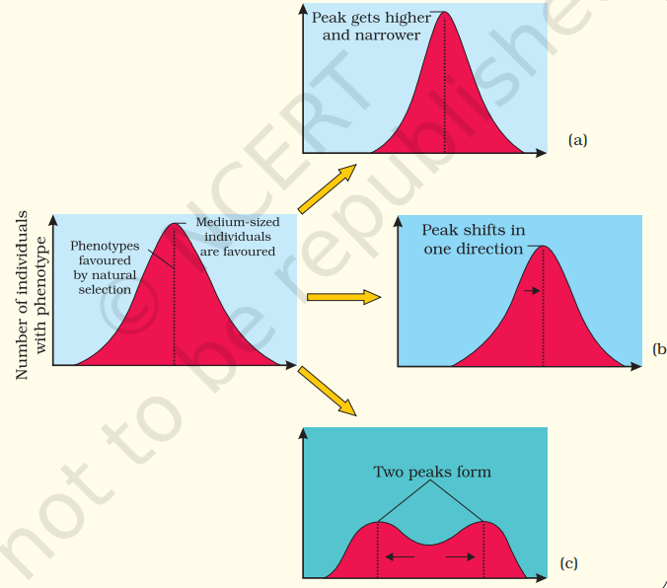

**Diagrammatic representation of the operation of natural selection on different traits : (a) Stabilising (b) Directional and (c) Disruptive.**

3) Speciation

* [Speciation](https://youtu.be/SsKQCHmCIMI?feature=shared)
* [Types of Speciation](https://youtu.be/fAajKkjjLCQ?feature=shared)
* [Polyploidy and Aneuploidy animation](https://youtu.be/ZTVIRGCQwCc?feature=shared)

## Speciation

The process of **formation of a new species** from the pre-existing species is called speciation.Species is a group of similar organisms that can **interbreed** and produce a **fertile offspring** in nature.

## How speciation happens?

Speciation usually occurs when **barriers prevent gene flow** between populations. Over time, differences in genetics, behavior, or environment accumulate, leading to the formation of new species.

The **barriers** that lead to **speciation** are called **reproductive isolation mechanisms**.

### **1. Prezygotic Barriers *(before fertilization)***

These prevent the formation of a zygote (fertilized egg):

#### **a. Temporal Isolation**

* Populations breed at **different times** (day, season, or year)
* *Example:* One species mates in spring, another in summer

#### **b. Habitat Isolation**

* Species live in the **same area** but different **habitats**
* *Example:* One insect lives on leaves, another in the soil

#### **c. Behavioral Isolation**

* Different **mating behaviors** or **courtship rituals**
* *Example:* Different bird songs or dances attract different mates

#### **d. Mechanical Isolation**

* Reproductive organs are **not compatible**
* *Example:* Insects with different shaped genitalia

#### **e. Gametic Isolation**

* **Sperm and egg cannot fuse** even if mating occurs
* *Example:* Marine species releasing gametes into water

### **2. Postzygotic Barriers *(after fertilization)***

These occur **after the zygote is formed**, preventing the development of fertile offspring:

#### **a. Hybrid Inviability**

* The zygote/embryo **doesn’t develop properly** or dies early

#### **b. Hybrid Sterility**

* Offspring is born but **sterile**
* *Example:* Mule (offspring of horse and donkey)

#### **c. Hybrid Breakdown**

* First generation hybrids are fertile, but their **offspring are weak or sterile**

## Types of Speciation:

#### **Allopatric Speciation**

* Occurs due to **geographic isolation** (e.g., a mountain or river separates populations)
* Genetic differences build up → new species
* *Example*: Darwin’s finches on different Galápagos islands

#### **Sympatric Speciation**

* Occurs **without physical separation**
* Caused by **genetic mutations**, **behavioral changes**, or **ecological niche differences**
* *Example*: Different food preferences in insects living in the same area

#### **Parapatric Speciation**

* Occurs when populations are **partially separated** (some overlap)
* Reproductive isolation develops gradually
* *Example*: Grass species growing in polluted vs. non-polluted soil

#### **Peripatric Speciation**

* A small **isolated sub-group** forms a new species
* Similar to allopatric, but involves **small population size**
* *Example*: Island colonization by a few individuals

4) Adaptive Radiation

* [Adaptive Radiation and evolution](https://youtu.be/-b3tFfbw_EU?feature=shared)
* [complete overview +examples](https://youtu.be/su-ngW37bxU?si=Z_r1o8s2IZRnEhdn)

## Adaptive Radiation

The process of evolution which results in transformation of original species to many different varieties adapted to different ecological niches is called **adaptive radiation**.This process often occurs when a species colonizes a new environment, leading to the evolution of diverse traits to exploit available resources.

### Key Aspects of Adaptive Radiation:

* **Rapid Diversification**: Adaptive radiation is characterized by a sudden increase in the number and diversity of species within a short evolutionary time frame.
* **Adaptation to New Niches**: Organisms evolve to exploit new or different resources and habitats, leading to diverse adaptations.
* **Ecological Opportunity**: The presence of new or abundant resources, or a change in the environment, can create opportunities for adaptive radiation.

### Examples of Adaptive Radiation:

* **Darwin’s Finches:**

Darwin’s Finches is one of the best examples of adaptive radiation. During his visit to **Galapagos Islands**, Charles Darwin also noticed a variety of small birds. These birds are called Darwin’s finches.

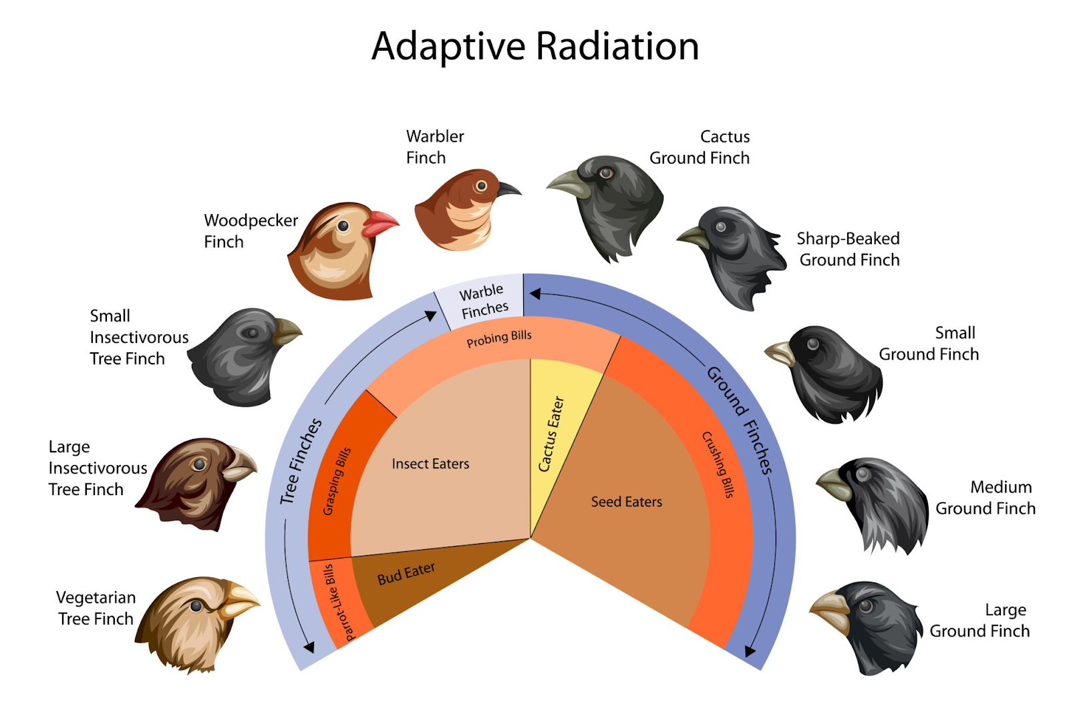

He noticed that the islands were home to several species of finches, each with a **unique beak shape** and **feeding behavior**. Interestingly, these finches were not found anywhere else in the world, but they all resembled a common bird species found on the **South American mainland**.

Darwin concluded that these island finches had **evolved from a common ancestor** — a mainland bird species that initially arrived at the Galápagos. As this ancestral population spread to different islands, the birds encountered **diverse environmental conditions** and **food sources**.

Over time, through **natural selection**, the finches' beaks gradually adapted to the specific diets available on each island:

* Finches that fed on **seeds** developed **strong, thick beaks**.
* Finches that ate insects evolved slender, pointed beaks.
* Others that fed on nectar or fruit developed specialized beak shapes suitable for those tasks.

This led to the emergence of **multiple finch species**, each specialized for a particular habitat or feeding strategy — all from one common ancestor.

Thus, Darwin’s finches became a classic example of **adaptive radiation**, showing how a single species can give rise to many different forms, each well-suited to its environment.

* **Australian Marsupials:**

A **marsupial** is a type of **mammal** that gives birth to relatively **undeveloped young**, which then continue to develop **outside the womb**, usually inside a **pouch** on the mother's body. For example: Kangaroos, Koalas, Wombats, Possums etc. **Placental mammals** have a **complex placenta** that nourishes the baby **inside the womb**. They give birth to **fully developed young**.

Millions of years ago, a **common marsupial ancestor** arrived in Australia, which was relatively isolated from other continents. Because of this isolation and the wide range of available habitats — forests, grasslands, deserts, and trees — these early marsupials were free to evolve in many directions without much competition from placental mammals (like in other parts of the world).

Over time, the original marsupial species **diversified** into many forms, each adapted to a different way of life. Here are some key examples:

* **Koalas** – adapted to life in eucalyptus trees, feeding on leaves
* **Kangaroos** – adapted for grazing in open grasslands and hopping as a form of movement
* **Wombats** – burrowers with strong claws, adapted to digging and living underground
* **Marsupial mice (dasyurids)** – small insect-eating marsupials, similar in role to shrews
* **Tasmanian devil** – a carnivorous scavenger, filling the role of a small predator

Though these animals look and behave very differently, they **all share a common ancestor** and have radiated out into various ecological niches — much like how placental mammals (like wolves, squirrels, and bears) evolved in other parts of the world.

Additional topics:

* [Neutral theory](https://youtu.be/tLjKM5i6BSU?feature=shared)
* [Molecular clock and neutral theory](https://youtu.be/zI5e3wn5O9Q?feature=shared)